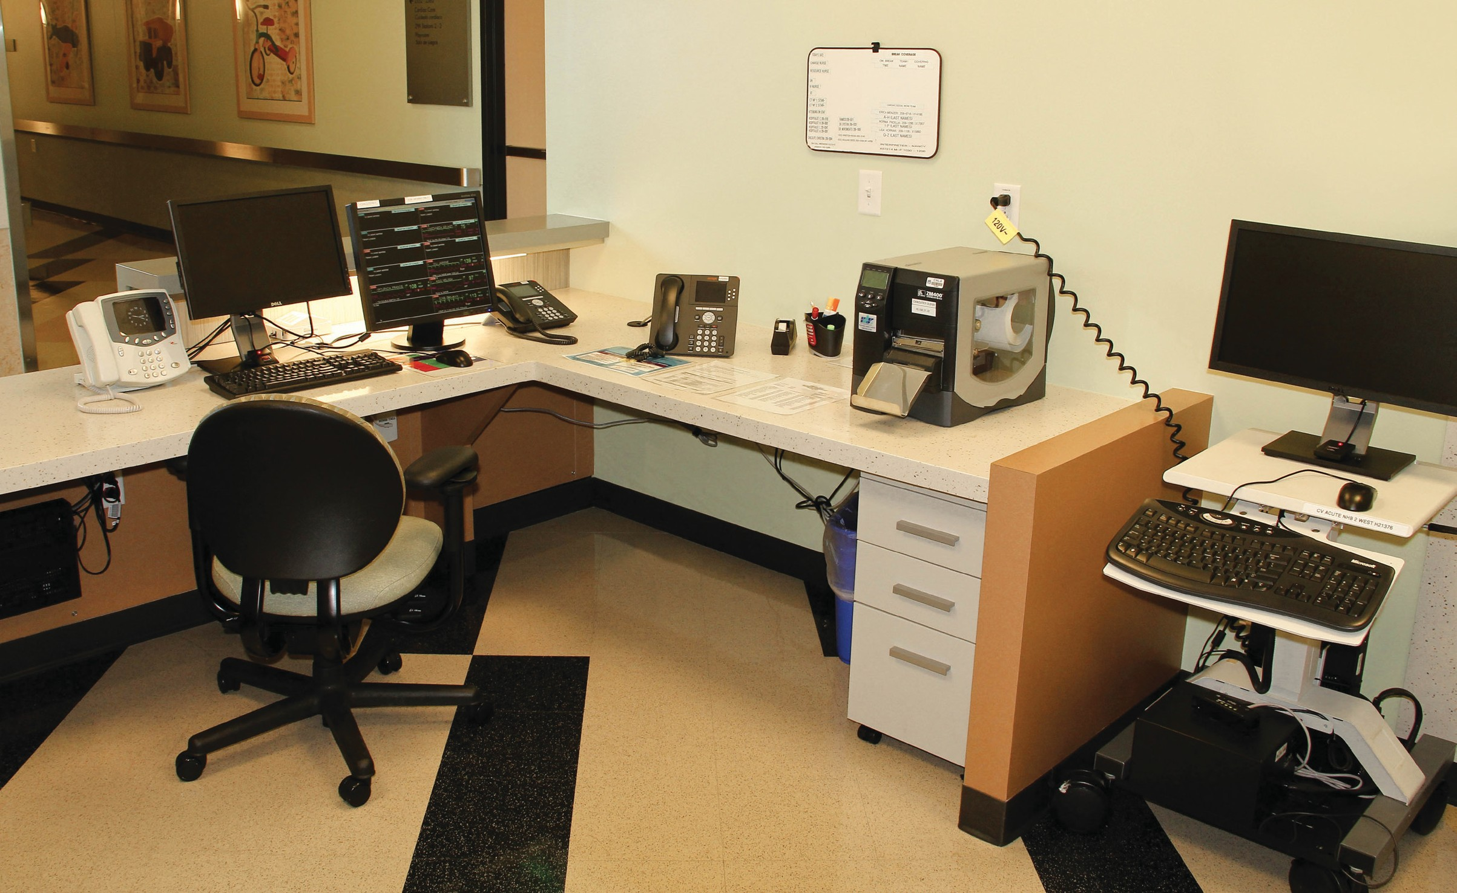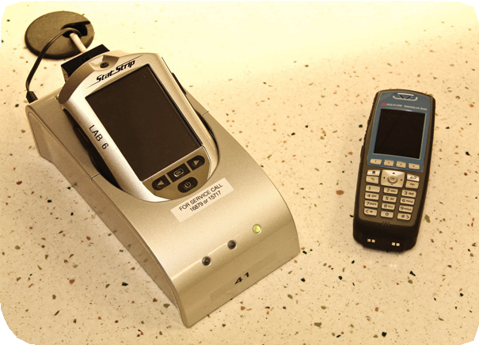

**Cleaning High-Touch Surfaces in Patient Care Areas**

## 4 2

6 2 4

3

1

1

5

3

8

7

**NURSES STATION**

v

### Equipment Approved to Clean with PDI Super-Sani Wipe: 2-Minute Contact Time

#### Desks and hard surfaces of chairs

1. Desk phones
2. Computer keyboards
3. Computer monitors
   * Clean only if visibly soiled
   * After contact time is elapsed—MUST clean touch-screen with water and wipe dry

#### Filing cabinets

1. Intercom system
2. Glucometer or Epoque Laboratory Handheld Device

**Equipment Approved to Clean with Dispatch Bleach Wipe: 5-Minute Contact Time for *Clostridium Difficile*, 1-Minute Contact Time for all other Organisms**

1. Polycom phones

**Cleaning High-Touch Surfaces in Patient Care Areas**

8

14 1

1

7

15

2

2

10 12 9

3

1

11 13

4 6

# STANDARD PATIENT ROOM – INTENSIVE CARE UNIT

v

### Equipment Approved to Clean with PDI Super-Sani Wipe: 2-Minute Contact Time

#### Boom

1. Syringe pump
2. Large-volume IV pump/ IV pole
3. Over-bed table
4. Bed/crib (not pictured)
5. Warmer or isolette
6. Patient monitor with touchscreen
   * After contact time is elapsed—MUST clean touch-screen with water and wipe dry

#### GetWellNetwork console

* + Clean only as needed if visibly soiled
  + After contact time is elapsed—MUST clean touch-screen with water and wipe dry

#### Ventilator

1. Parent chair and sleeping area
2. Supply cart—hard surfaces only
3. Computer on wheels
   * For Screens—After contact time is elapsed— MUST clean screen with water and wipe dry

#### Computer keyboard and mouse

1. Exam light
2. Privacy curtain
   * If patient is on Contact, Combined-Droplet, or Combined-Airborne Isolation, curtain must be changed during discharge cleaning
   * If patient is on Standard Precautions, curtain must be changed every six months

### If patient isolated for infection with *Clostridium Difficile*, Norovirus or Vancomycin-Resistant Enterococcus please use Dispatch wipe as cleaning agent.

